K means – Cluster Analysis Assignment

Question No.1: Imagine you have a dataset of customers of an online store. You have the following features for each customer:

Age: The age of the customer

Income: The annual income of the customer in thousands of dollars

Spending Score: A score from 1 to 100 indicating how much the customer spends in the store

Using the above dataset, your assignment is to perform k-means clustering analysis to group customers based on their age, income, and spending score. Follow these steps:

1. Import the dataset into your preferred programming language.
2. Normalize the data to ensure that all features are on the same scale.
3. Apply k-means clustering algorithm to group the customers.
4. Visualize the clusters to gain insights about the customer groups.
5. Once you complete the analysis, you can draw conclusions about the customer groups and make recommendations for the online store based on the findings.

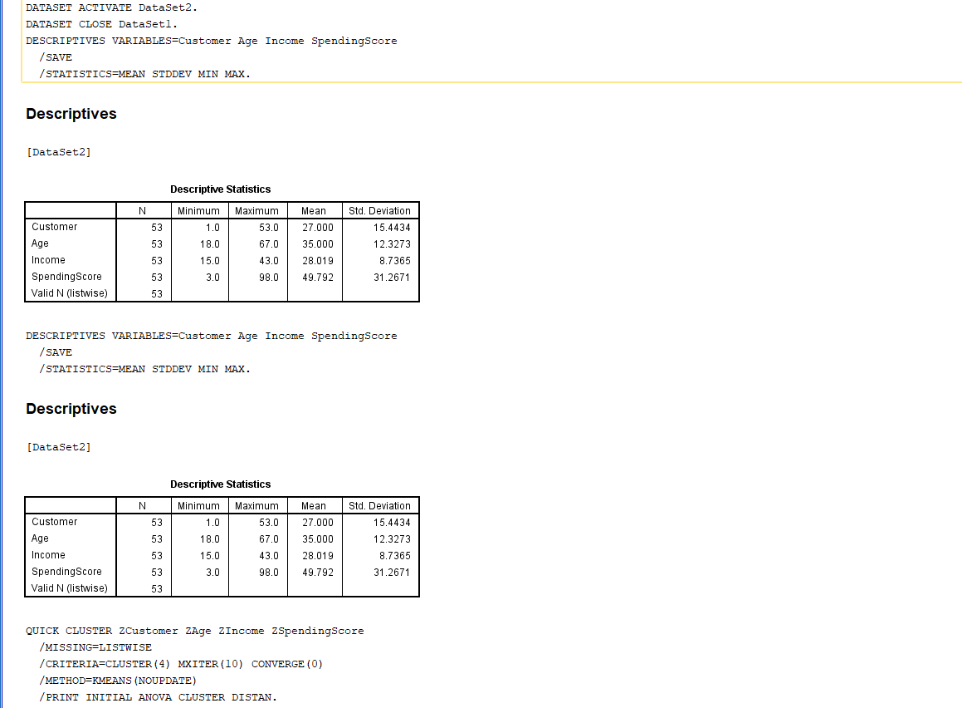

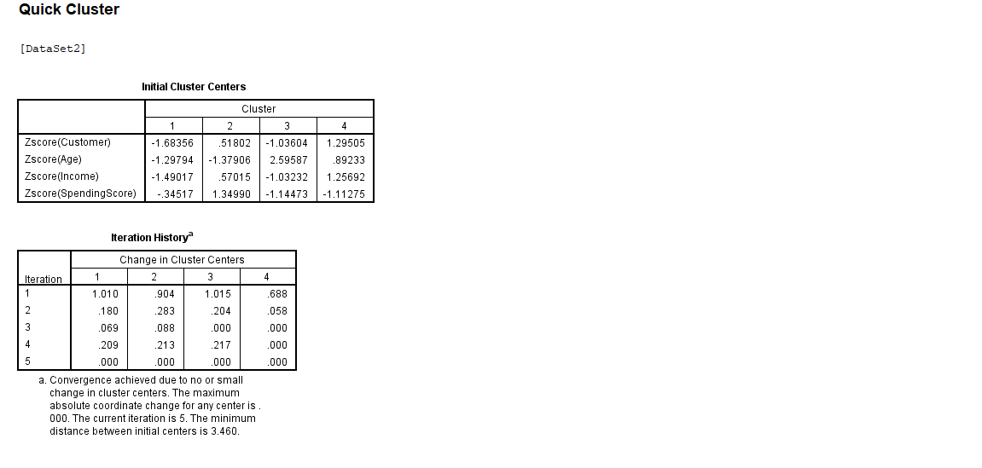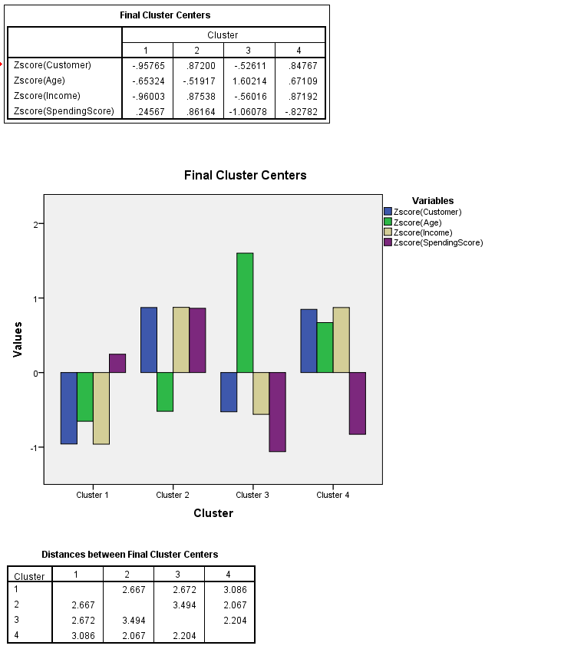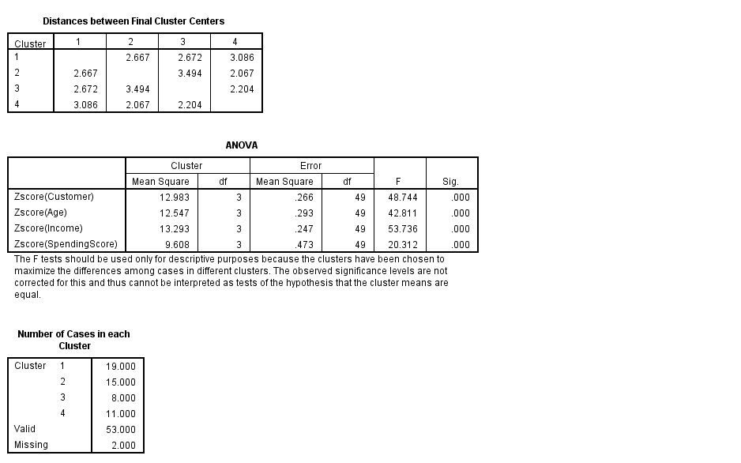Analysis:

The clustering effectively separates the data into groups based on the standardized variables.

Cluster 3 represents older customers with lower spending scores, while Cluster 4 likely consists of higher-income individuals with balanced spending behaviors.

Cluster distances can be used to understand similarities between clusters and refine strategies for targeting different customer segments.

Question No. 2: A company wants to segment their customers based on their purchasing behavior. They have collected data on the amount of money each customer spent on various product categories, such as food, clothing, electronics, and home goods.

1. Import the dataset into your preferred programming language.
2. Normalize the data to ensure that all features are on the same scale.
3. Apply k-means clustering algorithm to group the customers.
4. Visualize the clusters to gain insights about the customer groups.
5. Once you complete the analysis, you can draw conclusions about the customer groups and make recommendations for the online store based on the findings.

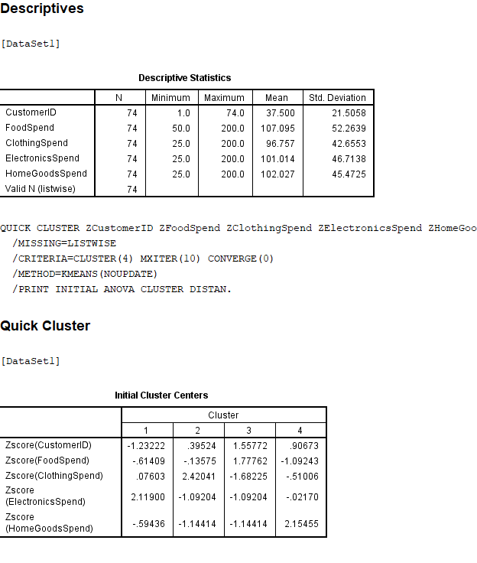

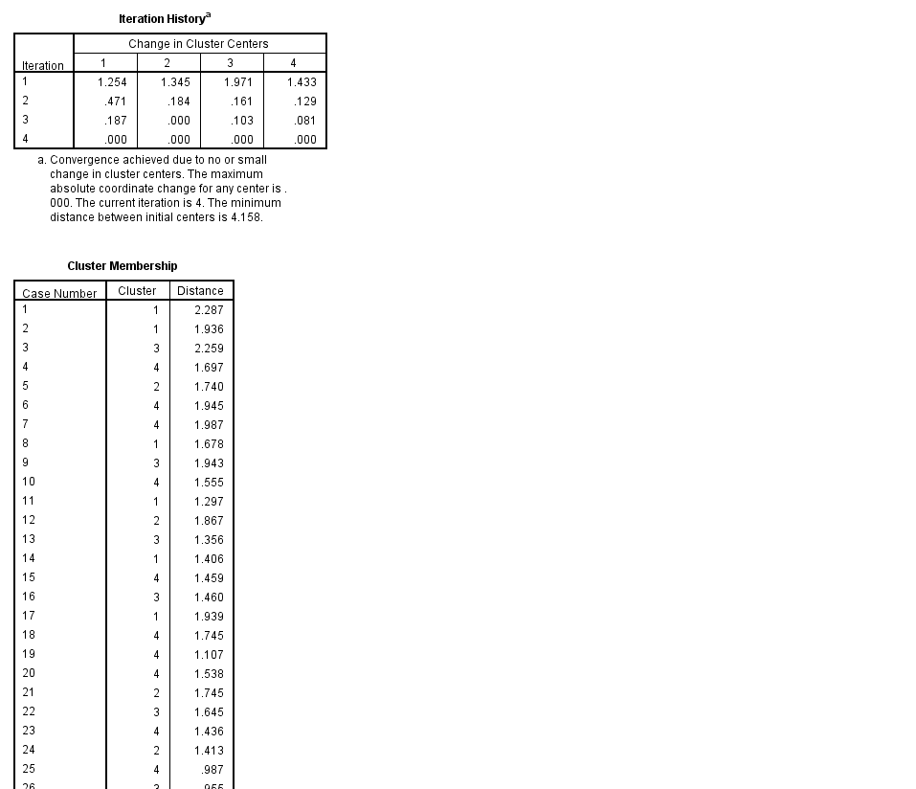

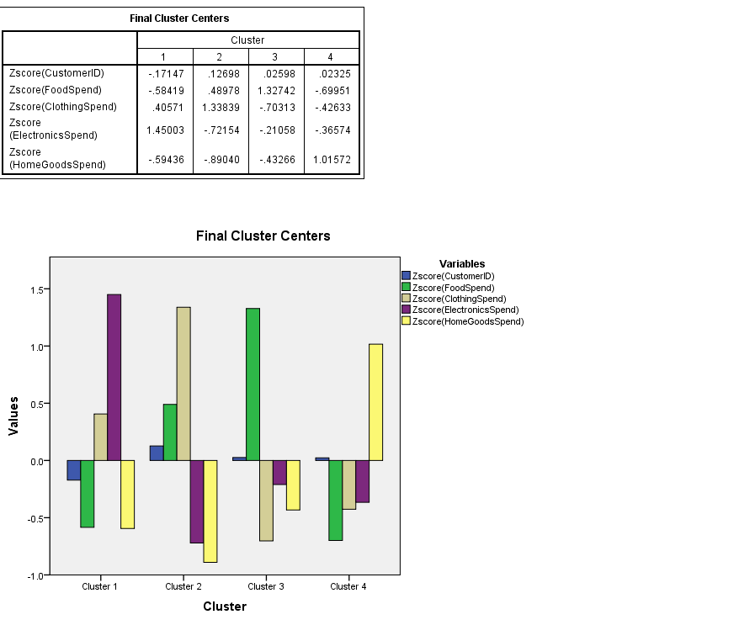

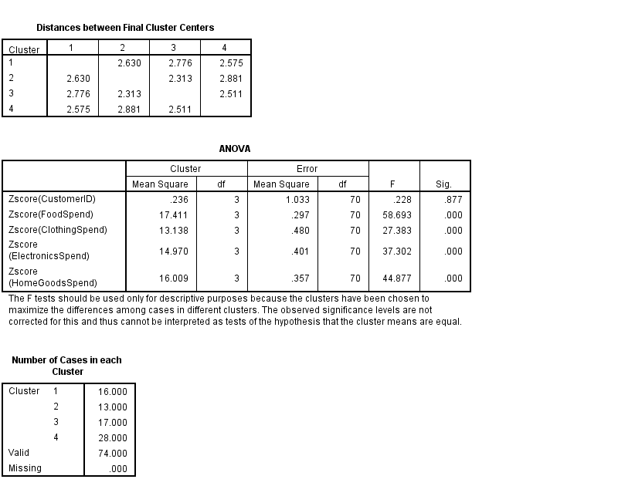

Analysis:

**Spending Patterns**:

The clustering separates customers based on their dominant spending categories.

Cluster 1: Electronics enthusiasts.

Cluster 2: Clothing-focused consumers.

Cluster 3: Primarily spends on Food.

Cluster 4: HomeGoods is the priority.

**Insights**:Businesses can tailor marketing and product strategies based on cluster-specific spending preferences. For example, targeting Cluster 1 with electronic promotions, while Cluster 3 might respond better to food-related deals.

**Applications**:These insights could be used for personalized marketing, inventory management, and designing customer-centric loyalty programs.